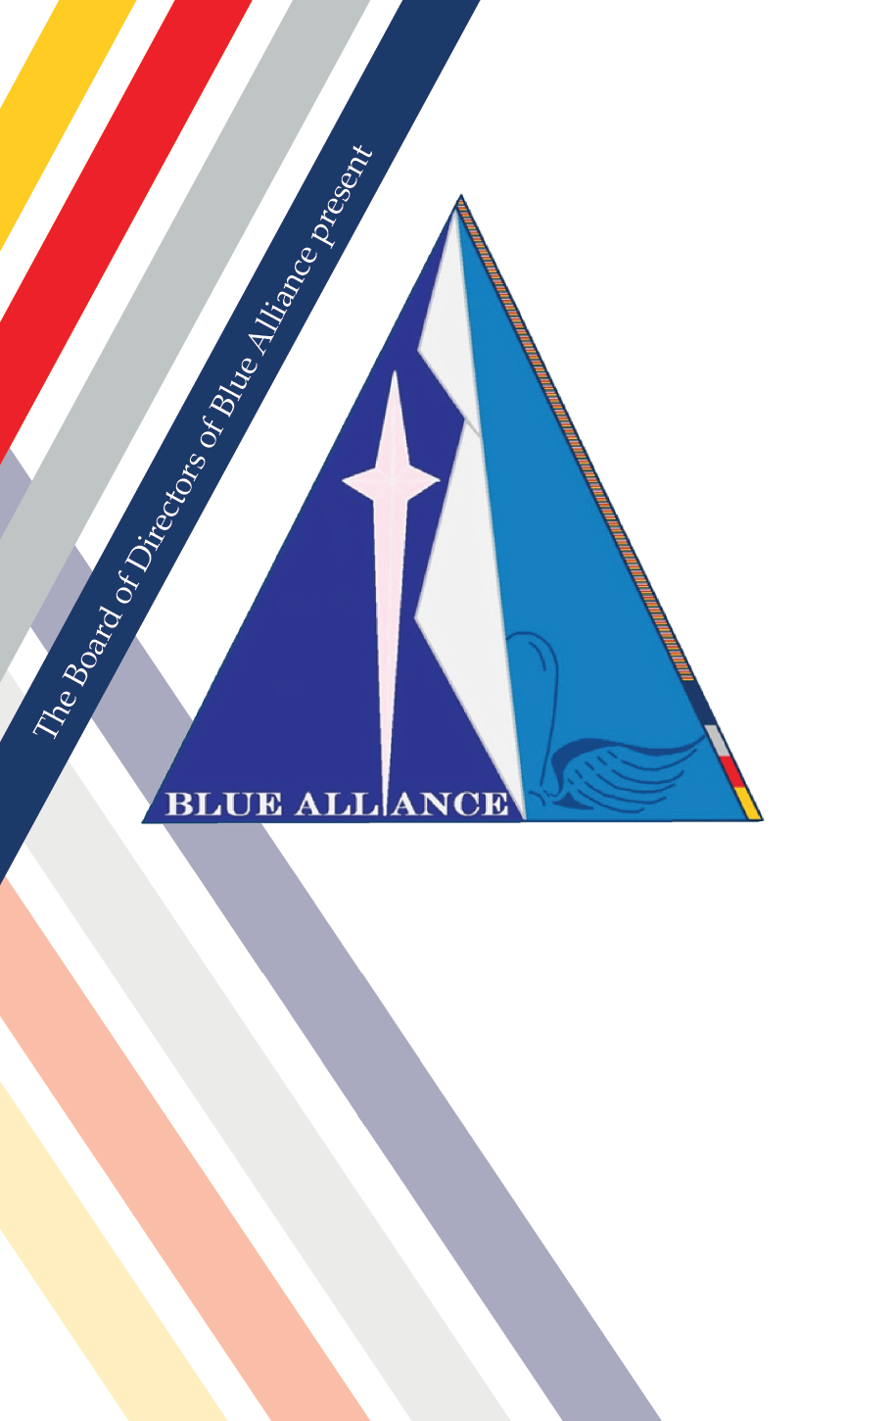

**Historic Preservation**

**October 1, 2022**

**Eisenhower Golf Course, USAFA, Colorado**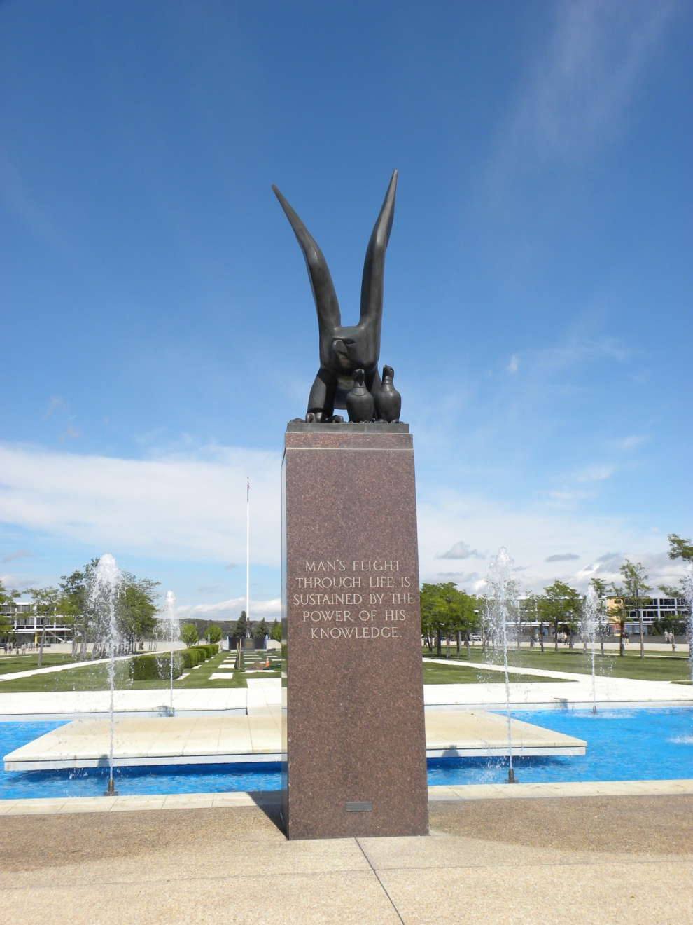

Man’s flight through life is sustained by the power of his knowledge.

*The Eagle and Fledglings, USAFA Terrazzo*

Our Purpose for Tonight

*Historic Preservation*

“Historic preservation is a conversation with our past about our future. It provides us with opportunities to ask, ‘What is important in our history?’ and ‘What parts of our past can we preserve for the future?’ Through historic preservation, we look at history in different ways, ask different questions of the past, and learn new things about our history and ourselves. Historic preservation is an important way for us to transmit our understanding of the past to future generations.

Our nation's history has many facets, and historic preservation helps tell these stories. Sometimes historic preservation involves celebrating events, people, places, and ideas that we are proud of; other times it involves recognizing moments in our history that can be painful or uncomfortable to remember.”

-National Park Service

Blue Alliance encourages our membership and Spectrum cadets to engage in “Historic Preservation”, so we remain aware and vigilant in protecting the precious rights and freedoms we have secured.

The Blue Alliance Logo

*Explained*

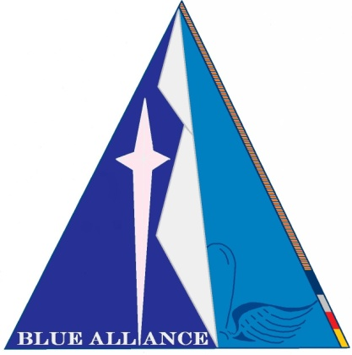The triangle shape was chosen to depict the journey of the Air Force, the Academy, and each Cadet and graduate into a distant, sometimes unclear future. This triangle is dissected by the cross-section of the tetrahedron that form the spires of the Cadet Chapel.

The words Blue Alliance form the foundation of the dark-blue left section of the triangle, forming a beacon in the dark.

The Polaris Star dominates the left section, in a pink hue, that represents our slightly differing perspective on navigating an uncertain future.

The right side of the triangle is lighter, showing our hope for a brighter future built on the common imprint of our Academy experience, depicted by the Cadet Prop and Wings insignia, on our collective character.

The stripes on the right-hand band are based on the four class colors of the current Cadet Wing, tapering off in a growing line of class colors into the past....a past built on the contributions of those brave LGBT graduates who went before us.

Honored Guest

*Zoe Dunning (USNA ’85)*

Commander Zoe Dunning, SC, USNR (Ret.) was born in Milwaukee, Wisconsin. She was nominated to the United States Naval Academy by her Congressman James Sensenbrenner and graduated with the Class of 1985 with a Bachelor of Science Degree. After graduation from Annapolis, she was commissioned an Ensign in the Navy Supply Corps. After attending Navy Supply Corps School in Athens, Georgia, she was assigned to the USS Lexington homeported in Pensacola, FL.

At the end of her obligated active duty service, she transferred into the United States Navy Reserve and attended Stanford Graduate School of Business in Palo Alto, California.

Commander Dunning retired from the Navy Reserve in 2007 after 22 years of service as a commissioned officer in a ceremony on board the USS Hornet (CV12) in Alameda, California.

On December 22, 2010, Commander Dunning stood beside President Barack Obama as he signed the Don't Ask, Don't Tell Repeal Act of 2010.

Today, Zoe leverages her experience as a consultant and facilitator specializing in working with leadership teams to help clarify vision, mission and values and align organizations around them. She provides this for a wide range of clients at Future State, a women-owned, employee-owned management consulting firm with headquarters in Oakland. She also continues to be active in support of veterans and the LGBTQ community. She serves on the advisory board of VetsInTech, an organization that supports veterans transitioning to civilian life gain access to education, employment and entrepreneurial opportunities in the tech sector. Additionally, Zoe also serves as a member of the US Air Force Academy Board of Visitors.

From The Ramparts

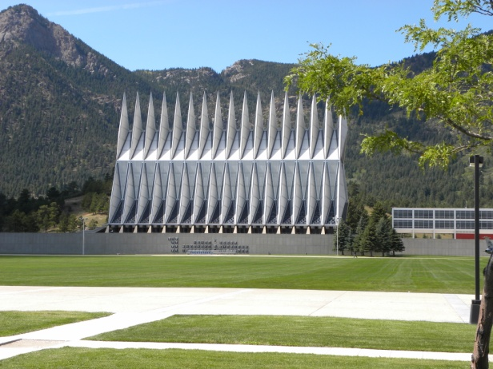

From the ramparts we will go into the sky,

Far away from comrades here.

To whatever fate may bring:

Fame, or Glory, even Death.

But no matter what may come,

Life is better, purpose more, honor bright

Because ‘twas here we first beheld,

What greater thing could be.

ꟷ “a Proposed Hymn for the Cadet Wing” by Clifton Williams, March 1965

Historic Preservation

*Event Agenda*

10:00am **Falcons Beat Navy** Falcon Stadium

2:30pm **Open Bar and Networking** Eisenhower Golf Course

3:15pm **Buffet Meal**

3:45pm **2022 Flight of Heroes Inductee 2022: *Karl Alvarez***

Introduction and Presentation by Tricia Heller and Regina Brown

4:00pm **Keynote Speaker**

Kathi Durst

5:00pm **Thanks and Acknowledgements**

Jeff Breininger



Blue Alliance

*Flight of Heroes*

“ONE WAY TO REMEMBER WHO YOU ARE IS TO REMEMBER WHO YOUR HEROES ARE.” - Steve Jobs

In 2007, a small clutch of out-and-proud graduates of our United States Air Force Academy began to conceptualize and implement the charter for a support network for lesbian, gay, bi-sexual, and transgender [LGBT] graduates, cadets, faculty, and allies - BLUE ALLIANCE - and that organization has withstood the test of time and honored its charter. Throughout this journey, we have also witnessed uncountable, quiet acts of heroism and character. We were inspired by these demonstrations of character and leadership and committed to recognizing these heroes in our midst, from our community, on a recurring basis.

The Board of Directors of Blue Alliance therefore, created an award: The BLUE ALLIANCE FLIGHT OF HEROES - recognizing the cadet, alumnus, faculty, or ally who best demonstrates the ideals of courage, leadership, humanity, integrity, accomplishment, and loyalty at the center of our shared experience within the Air Force Academy. It is our sincere hope that Flight of Heroes inductees will serve as role models for cadets and graduates to remember who they truly are.

**PREVIOUS INDUCTEES:**

|  |  |
| --- | --- |
| Dr. Steve Samuels | - USAFA Dept. of Behavioral Science and Leadership |
| Darrell Slack (‘85), Jeff Breininger (‘85), Tricia Heller (‘87), and Greg Mooneyham (‘87) | - Founding Blue Alliance Board Members |
| Dan Dwyer (‘12), Shaina Thompson (‘12), and Andrew Jacobs (‘12) | - Founding Spectrum Cadets |
| Brig. General (ret) Gary Packard (‘82) | - Permanent Professor and Chair of USAFA Behavioral Sciences and Leadership Dept. |
| William “T” Thompson (‘73) | - Executive Director USAFA Association of Graduates |
| Gary Howe (‘69) | - Executive Vice President USAFA Association of Graduates |
| Brig. General Andrew Armacost  Bill Oliver | - USAFA Dean of Faculty  - PFLAG Colorado Springs |

**2022 Flight of Heroes Inductee**

*Karl Alvarez (’84)*

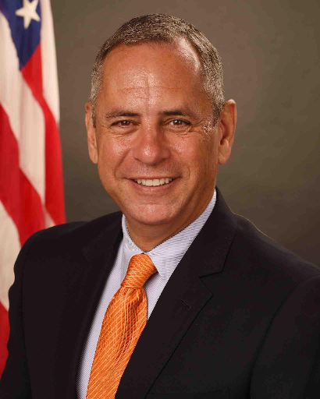**Mr. Karl Alvarez, USAFA Class of 1984**, is the 2022 inductee to the Blue Alliance Flight of Heroes, in recognition of his vast contributions and inspiration to Blue Alliance.

Karl was one of the earliest members of Blue Alliance and was instrumental in our efforts to stand up a proud and professional organization. As a former Air Force Protocol Officer, his wisdom and expertise provided the outstanding structure for this annual dinner and program, appropriately hosting and honoring members of Congress, as well as senior Department of Defense leadership and other dignitaries throughout the years.

Karl has also represented Blue Alliance throughout the Washington D.C. sector, amongst all levels of leadership, government and affiliate organizations, allowing our presence to grow and provide a network of support and action for any number of causes and issues we have faced. He was also the driving force behind the Flight of Heroes award, to account for, and preserve our history for generations to come.

Most notably though, Karl’s artistic talents, combined with his understanding and respect of history and symbolism, was the creative genius behind our Blue Alliance logo, a gift beyond comparison to our organization and membership.

The Board of Directors struggles to adequately express our thanks and admiration of Karl Alvarez. He is truly a hero and an inspiration. “Here’s a Toast”

**Diversity, Equity and Inclusive**



“When we listen and celebrate what is

both common and different,

we become a wiser, more inclusive,

and better organization.”

- Pat Wadors

**Keynote Speaker**

*Kathi Durst*

Being a trailblazer is nothing new for Captain Kathi Durst. In 1981 she graduated from the U.S. Air Force Academy, in only the second class that admitted women. In 2012, Captain Durst also became the first female pilot in a Fleet management leadership role in American Airlines’ history when she stepped up to assume the Fleet Captain position for the Boeing 737 fleet. Two years later in 2014, Captain Durst broke new ground. She was named one of four Chief Pilots at American's largest hub, DFW — the first woman to carry this mantle. Captain Durst is a former Check Airman (Instructor Pilot) on both the Airbus A300 and Boeing 737 fleets before taking over the Boeing 737 Fleet Captain role. She currently instructs for American Airlines on the Boeing 777 fleet.

Upon graduating from the U.S. Air Force Academy in 1981, Captain Durst spent her seven-year Air Force career flying the Northrop T-38 at Williams AFB in Phoenix. In that time, she was an Instructor Pilot, Check Section Evaluator, Academic Officer, and the Student Squadron Executive Officer. While in Arizona, she earned a Master’s degree in Aeronautical Science from Embry-Riddle Aeronautical University.

Kathi has also spent a great deal of time mentoring young pilots through both the Women in Aviation International group and the National Gay Pilots Association, and is a passionate advocate for diversity and inclusiveness at American Airlines and in her community. To that end, Captain Durst was selected as a 2014 recipient of the 6th Annual Earl G. Graves Award for Leadership in Diversity. Additionally, she currently sits on the Board for Z.A.S.A. (Zoomies Against Sexual Assault) which combats sexual trauma at the Air Force Academy.

Kathi lives in Las Colinas, TX with her spouse Sheri, a retired American Airlines Flight Attendant

C:\Users\Public\Documents\BlueAllianceLogo v2.2.jpg ….Blue Alliance: *An Honorable Calling!*